# Cloud

1. Creating a Linux EC2 and deploying a html file on a public IP

* On your Console Home at the search bar, search for EC2   
  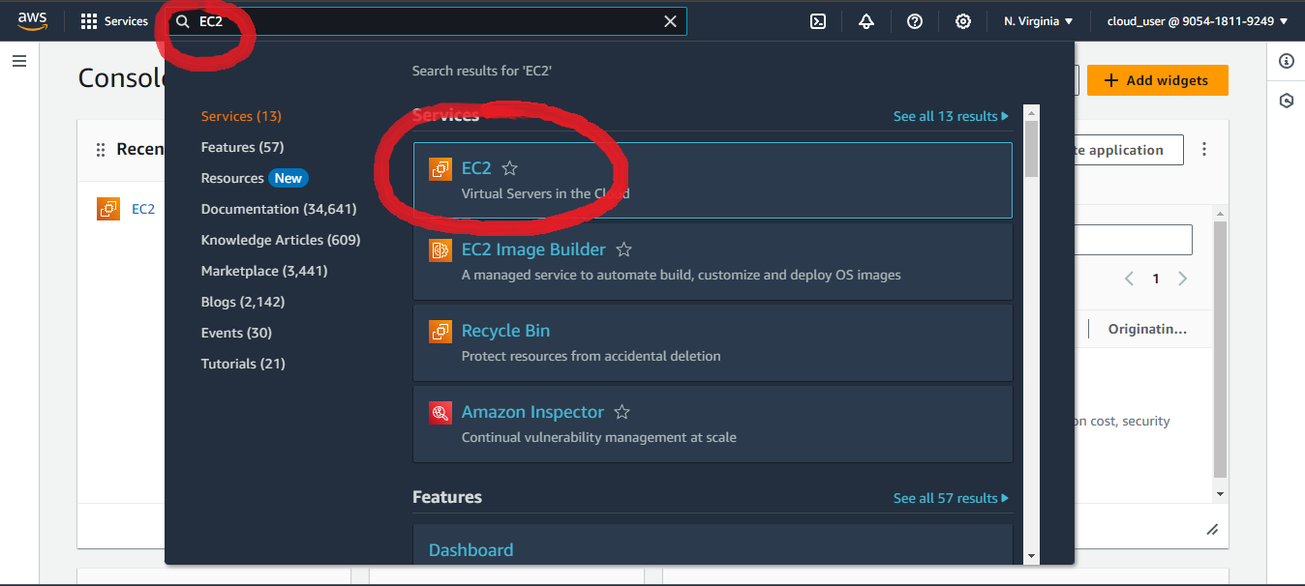
* At your EC2 Dashboard, look for Launch Instance and click on it   
  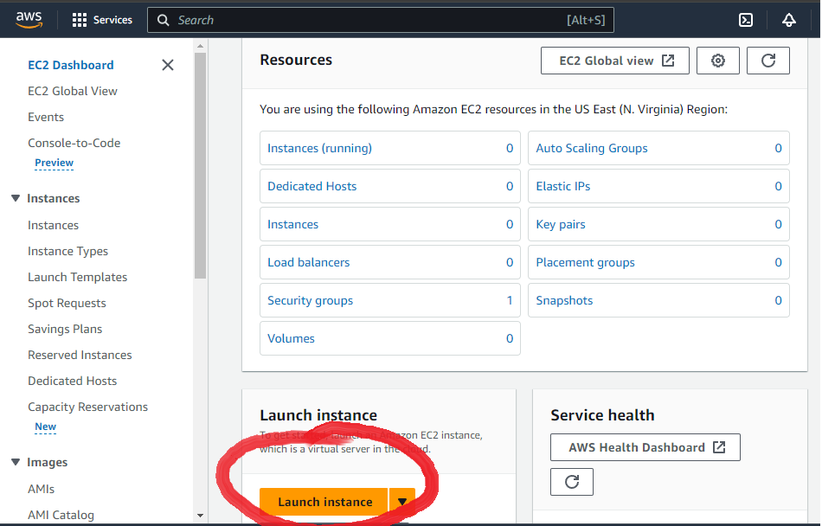
* On the next page, give your instance a name to identify it   
  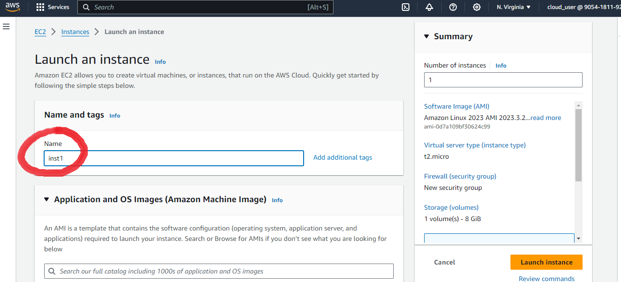
* Scroll Down from AMI’s choose Amazon Linux   
  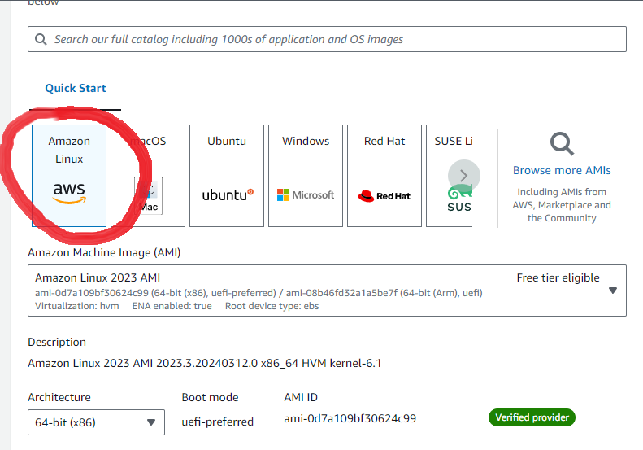
* In the next Instance type let it be set as default while in Key pair (login) Click on Create a new key pair  
  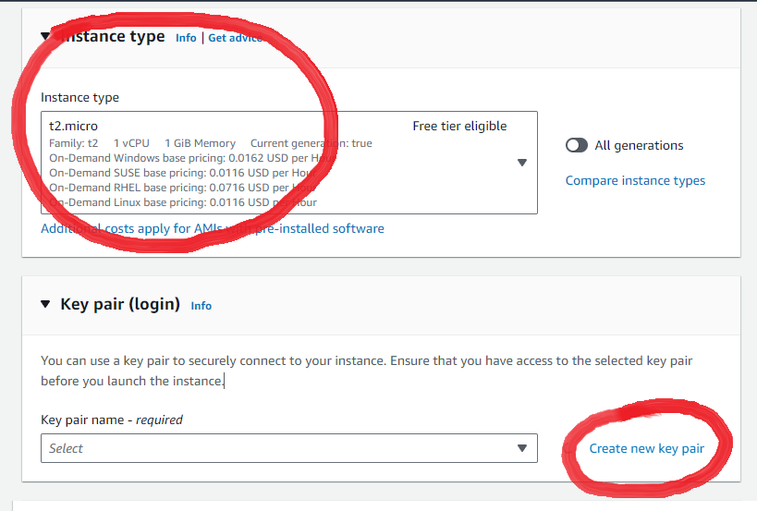
* At the next windows that pops up, type a name for your key pair, choose RSA type, and set the file format to .PPK and hit Create Key Pair  
  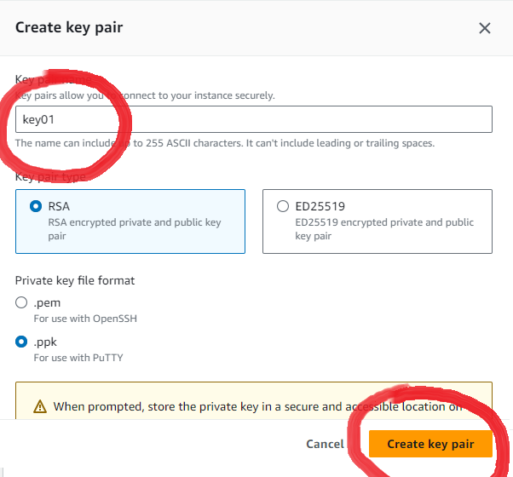  
  Save the generated key pair locally
* Scroll down under Network settings, Ensure all traffic is allowed   
  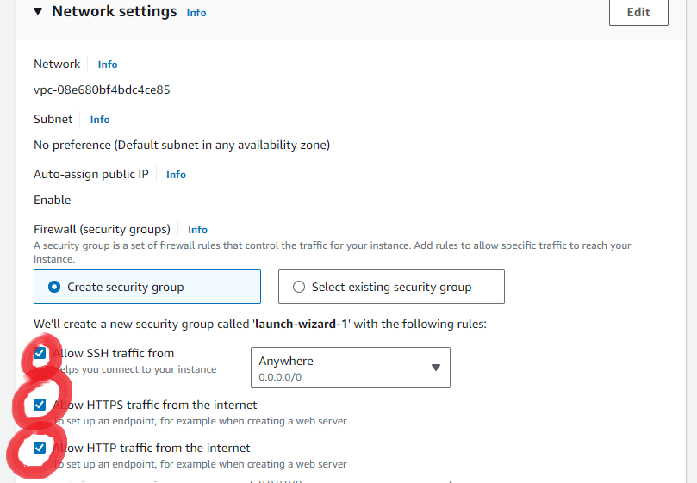
* And then leave all the options as is and hit Launch Instance   
  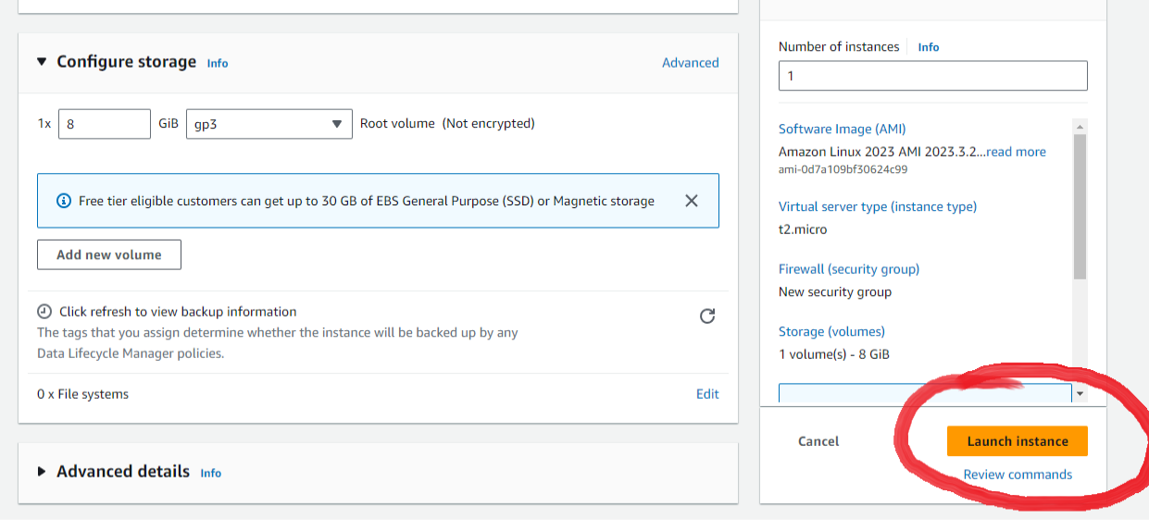
* Loading Page   
  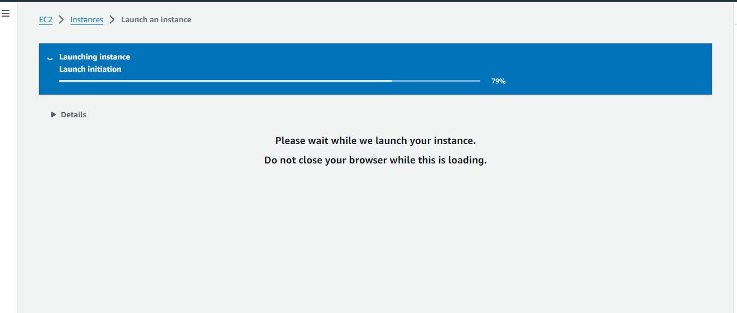
* Successful Creation   
  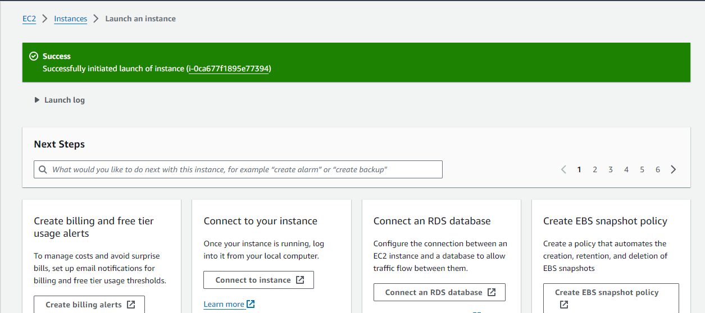
* Now navigate to EC2 dashboard to check status of our Instance   
  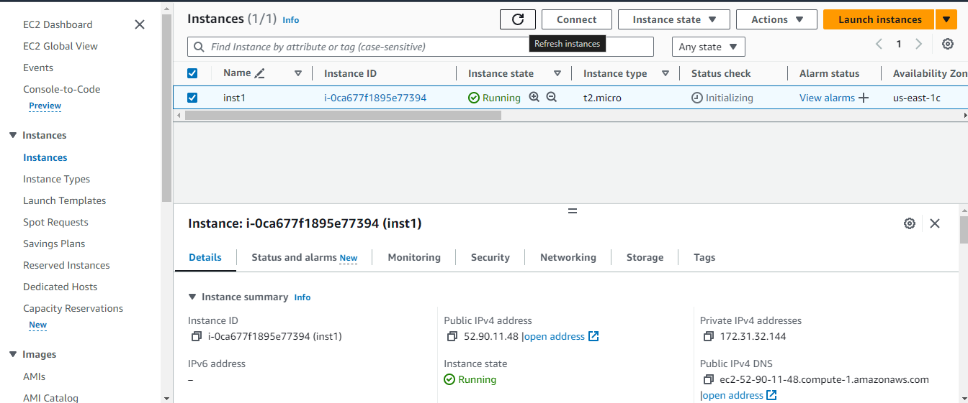  
  Once ensured it is running, We will Move onto Putty, Open Putty
* Type out your Hostname as ‘usernameofinstance’@’Public IPv4 Address’  
  In the Session box, the required info is annotated  
  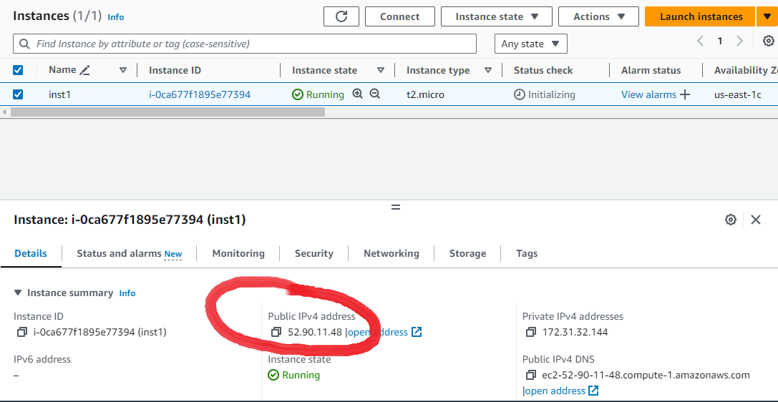  
    
  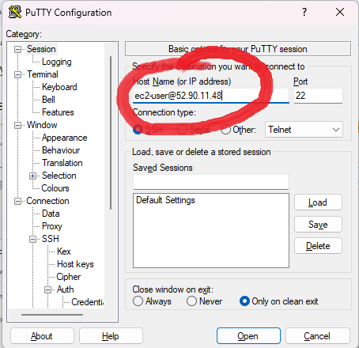
* Now from the left Categories pane on Putty Navigate to Connection → SSH —> Auth —> Credentials   
  Browse for the key pair you generated and add it into Private Key   
  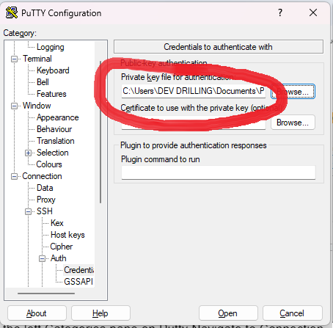
* Now, you can hit OPEN and a console should open connecting you to your instance   
  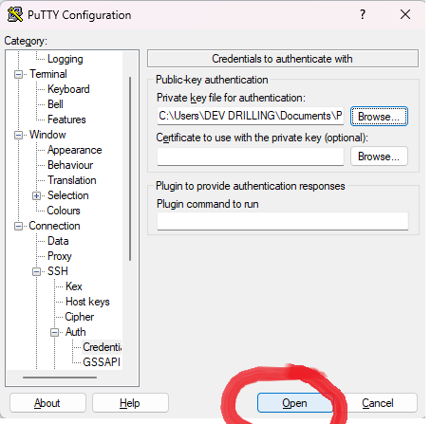
* At the next windows, Hit on accept   
    
  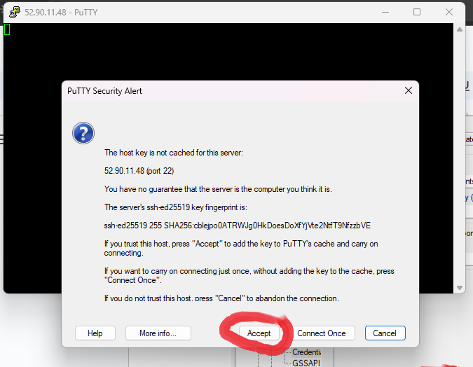
* On Successful connection   
  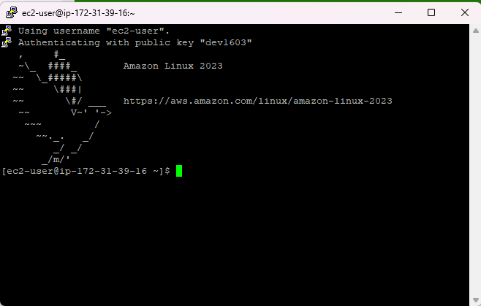
* Once you’re at the putty terminal type the following commands here

SUDO -I  
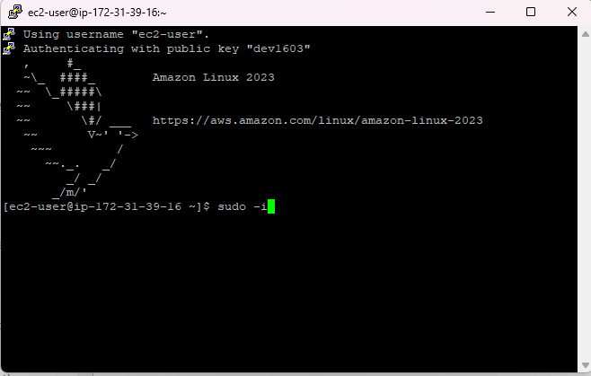

* YUM UPDATE -Y  
  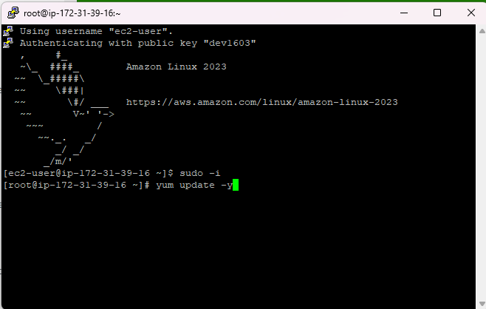
* YUM INSTALL HTTPD -Y  
  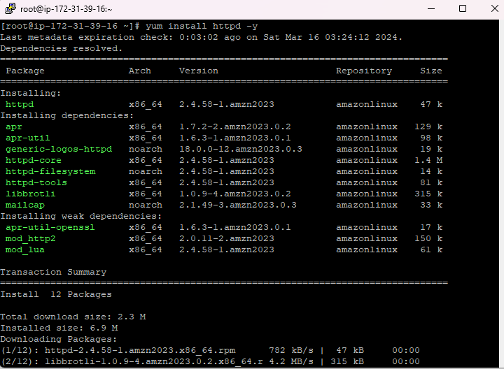
* SYSTEMCTL START HTTPD   
  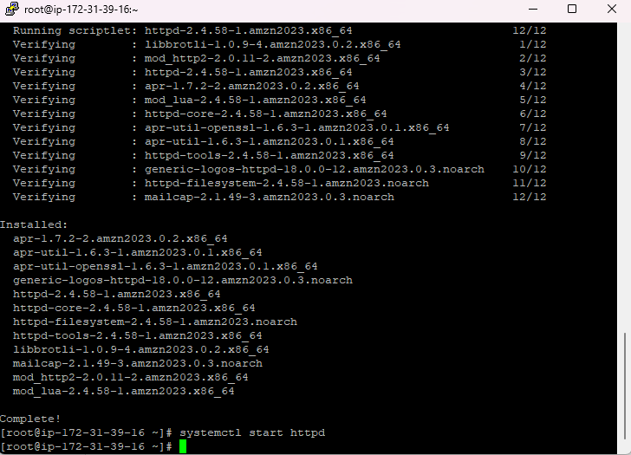
* SYSTEMCTL STATUS HTTPD  
  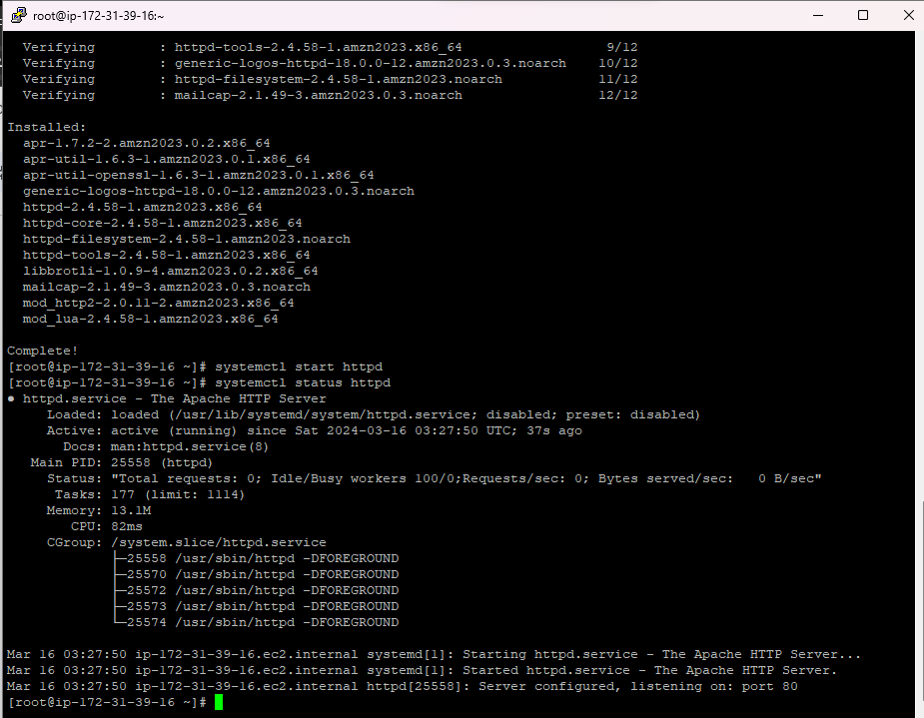
* SYSTEMCTL ENABLE HTTPD  
  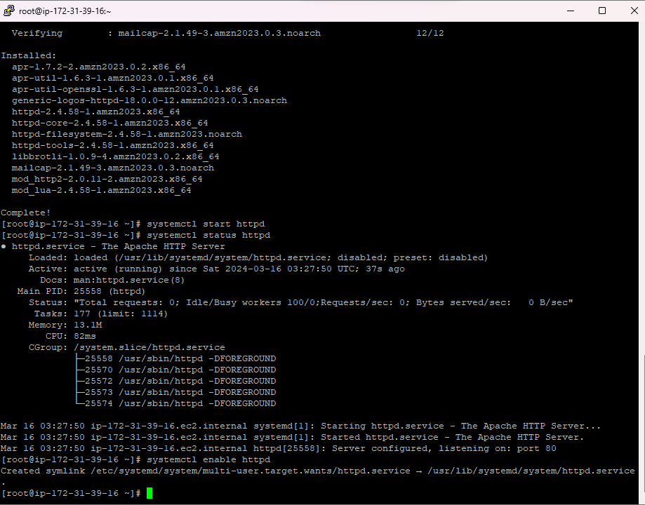
* Now navigate to /var/www/html   
  CD /VAR/WWW/HTML  
    
  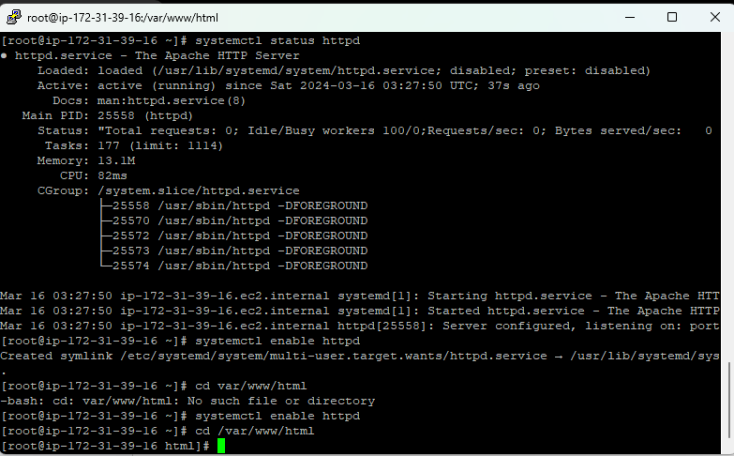
* Here open vi editor and create a html file with name index  
  VI INDEX.HTML and type your HTML CODE   
  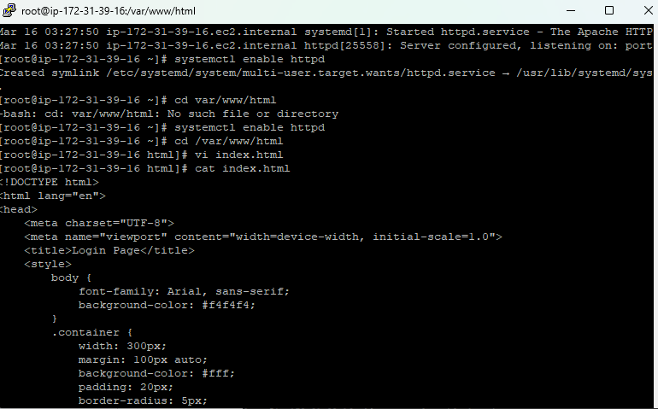
* Verify contents of your file using CAT   
    
  We now have successfully deployed a html page onto our EC2 Instance  
    
  VOILA !
* All we have to do now is to visit out IP, Final Screen

1. Creating an S3 bucket and uploading files onto it

* Navigate to S3 from your AWS Console   
  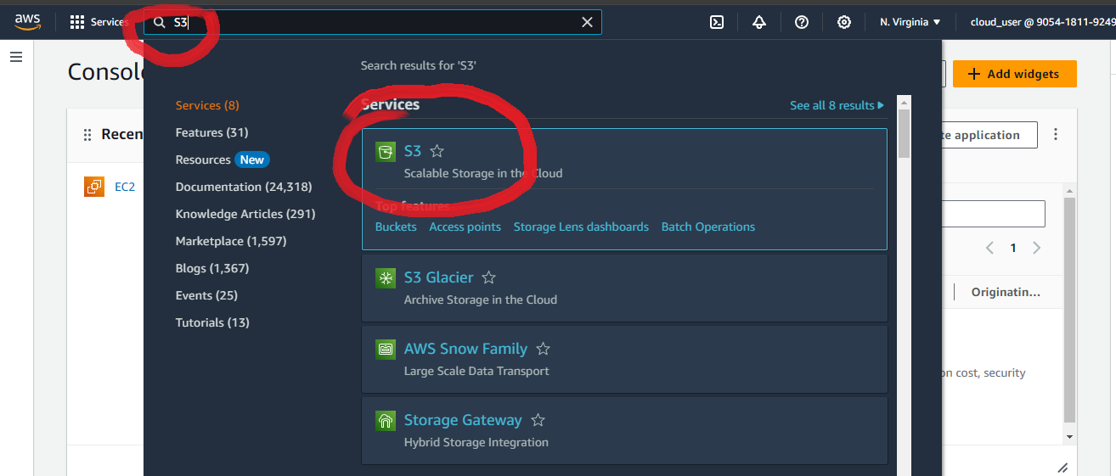
* On this page hit on Create a Bucket   
  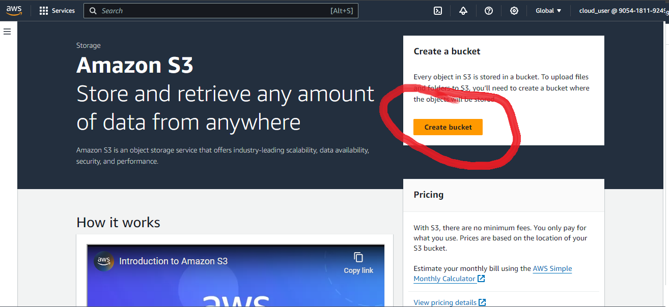
* On the landing page give your bucket a name   
  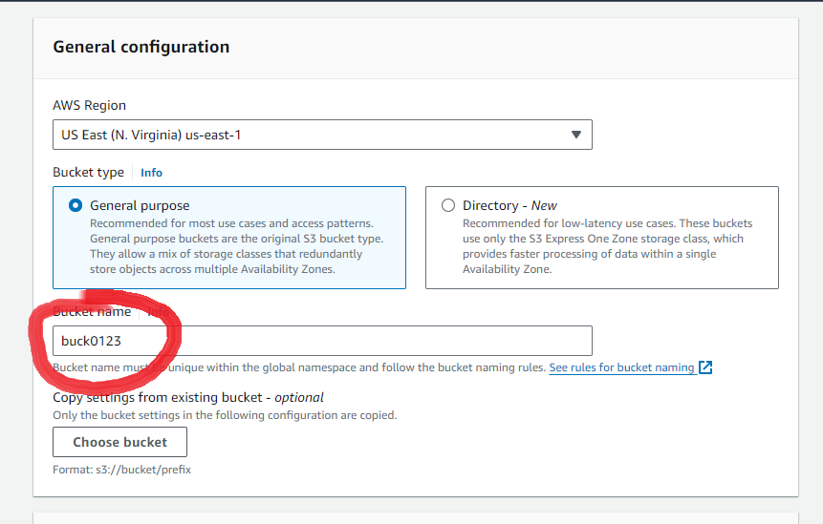
* In the Object Ownership options ENable ACL’s   
  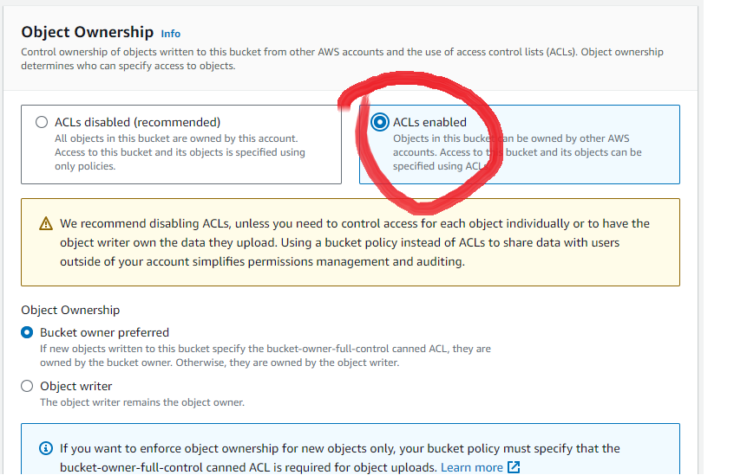
* In the block public access option. Uncheck everything which would look like so   
    
  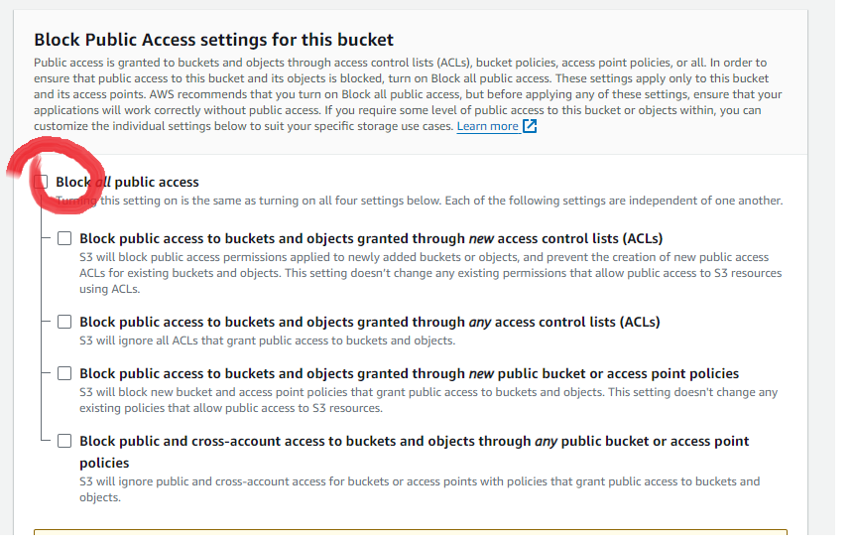  
  Ensure that you acknowledge public access   
  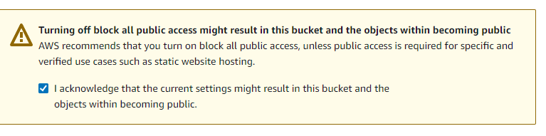
* After this leave all default options as it and hit Create Bucket   
  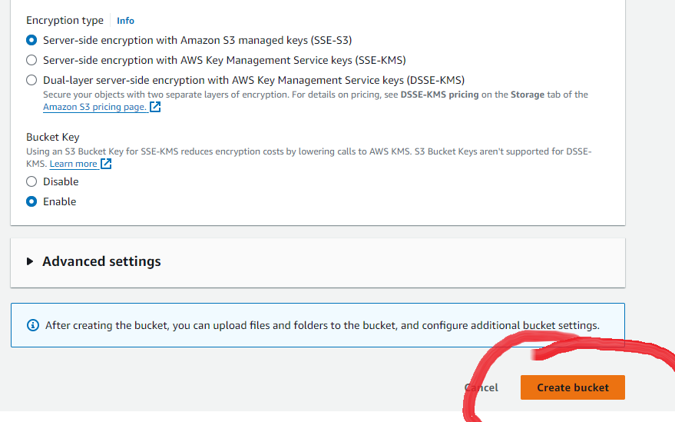
* Successful landing page   
  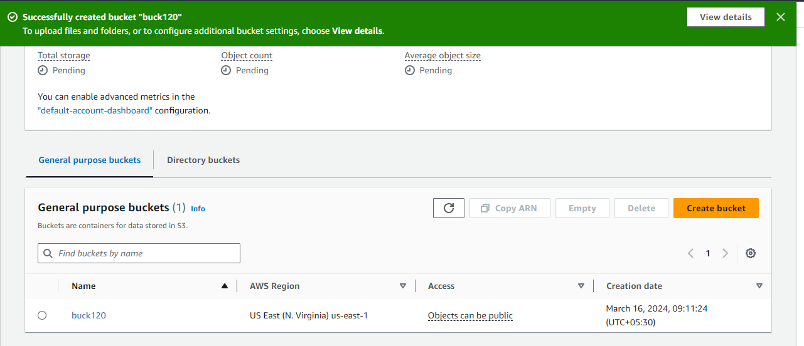  
  Navigate into your bucket, here you must see an Upload files box, Click on it and Pick a file from your PC   
    
  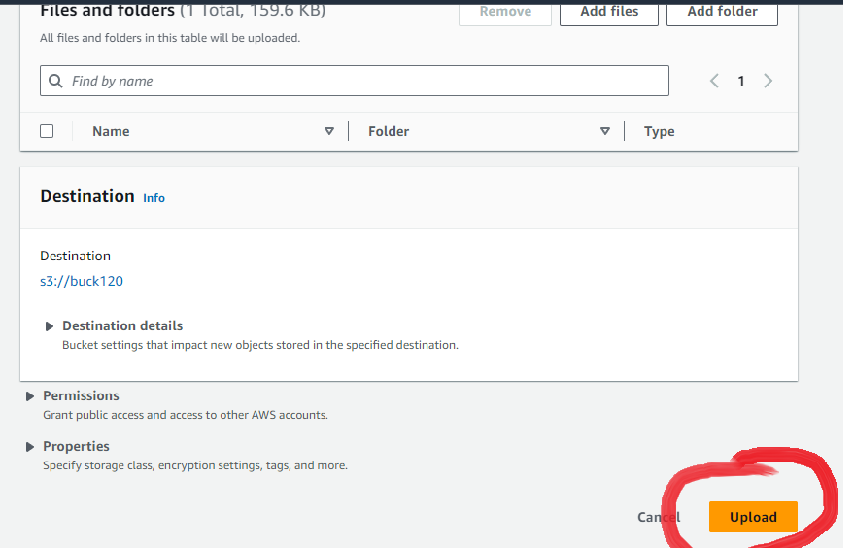  
  Click on Upload   
  Once uploaded the file would appear like so  
  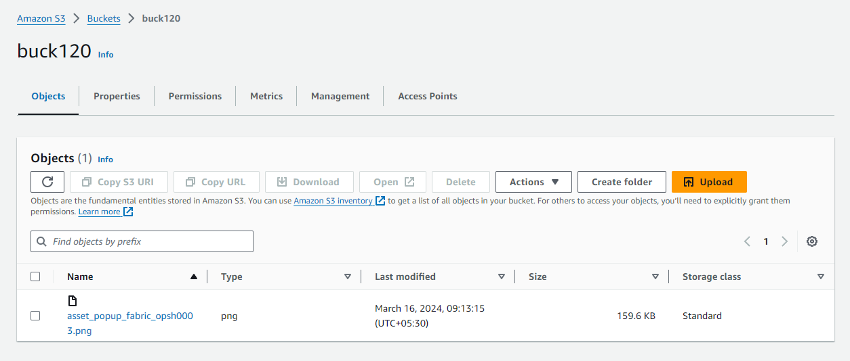  
    
  Select it, Press on Actions and Make Public using ACL   
  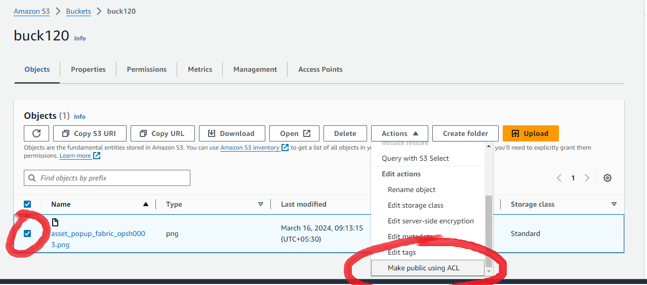
* Here Press on Make Public   
  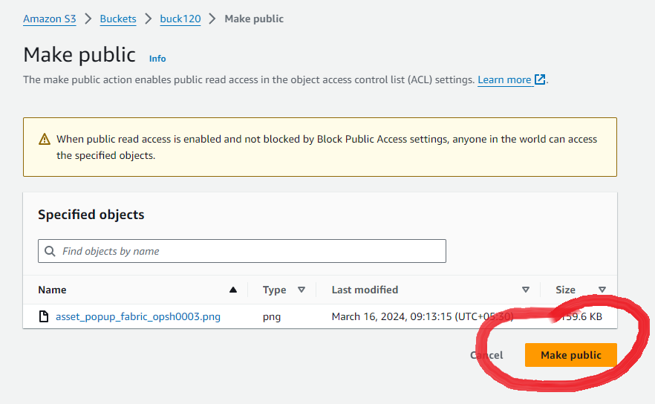  
    
  Now navigating back to your bucket and pressing OPEN, creates a new tab and opens your file   
    
  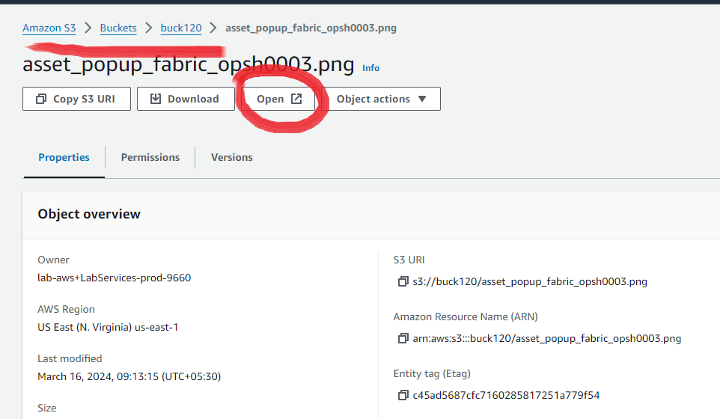  
    
  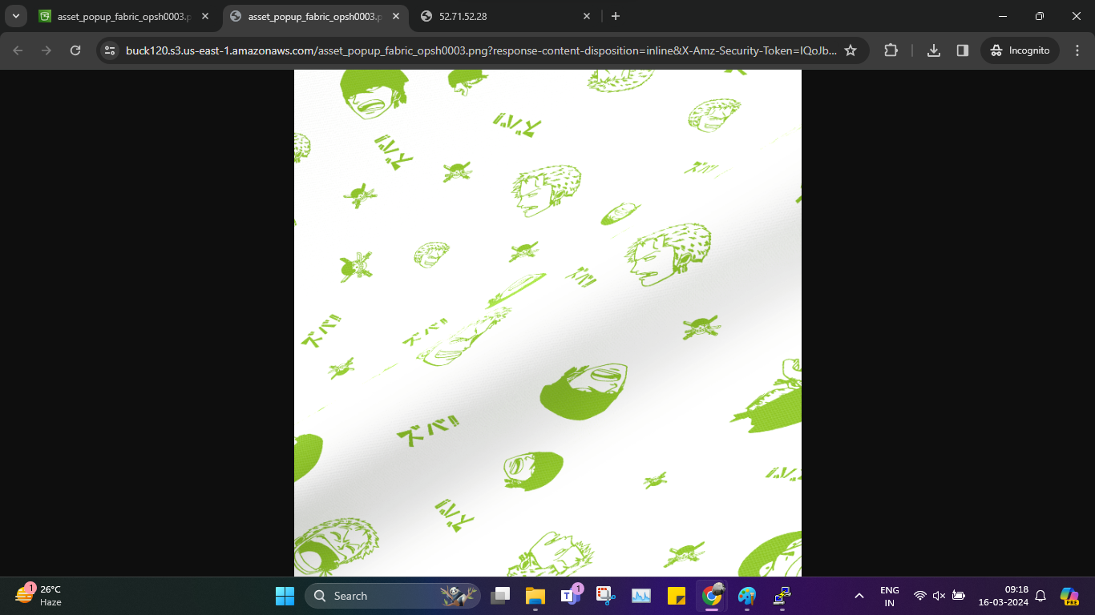

# SHELLL

1. Largest of three numbers   
     
   #!bin/bash

read -p "Enter first num: " i1

read -p "Enter second num: " i2

read -p "Enter third num: " i3

if [[ i1 -gt i2 ]] && [[ i1 -gt i3 ]]

then

echo "The greatest number is "$i1

elif [[ i2 -gt i3 ]] && [[ i2 -gt i1 ]]

then

echo "The largest number is: "$i2

else

echo "The largest number is: "$i3

fi

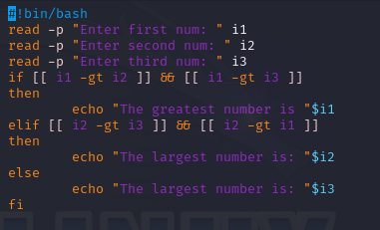  
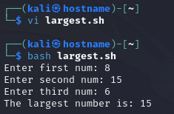

1. Shell Script to Display a menu program   
     
   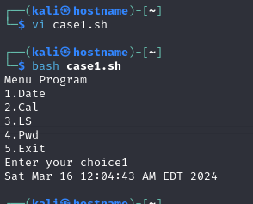  
     
   #!bin/bash

echo "Menu Program"

echo "1.Date"

echo "2.Cal"

echo "3.LS"

echo "4.Pwd"

echo "5.Exit"

read -p "Enter your choice" n

case $n in

1)date

;;

2)cal

;;

3)ls

;;

4)pwd

;;

5) echo "exit 0"

;;

esac

1. Linux Directory and FIle management script